**LeNet 5(1998)**

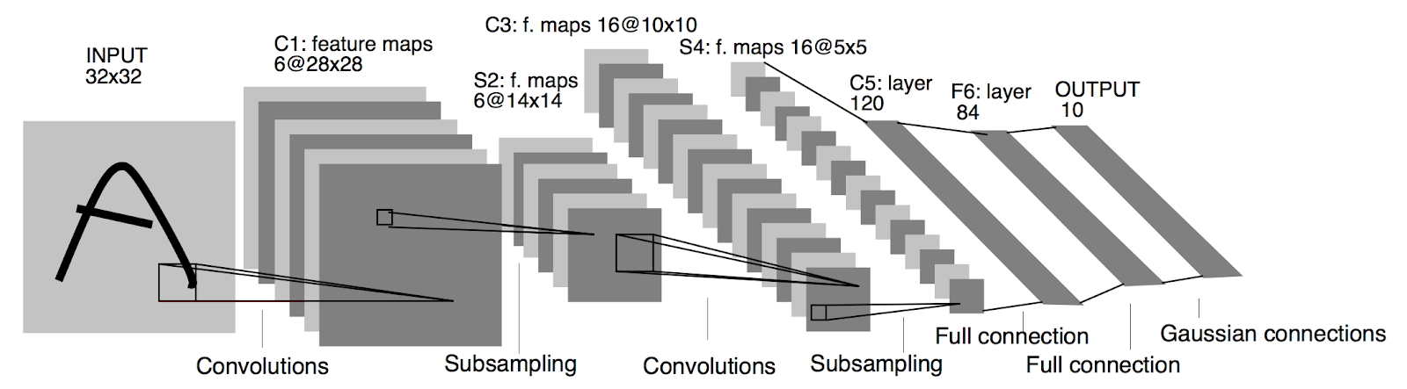

LeNet-5 is a very simple network.

* It only has 7 layers
* There are 3 convolutional layers (C1, C3 and C5)
* 2 sub-sampling (pooling) layers (S2 and S4)
  + 1 fully connected layer (F6)
  + output layer
* Convolutional layers use 5 by 5 convolutions with stride 1. Sub-sampling layers are 2 by 2 average pooling layers.
* Tanh sigmoid activations are used throughout the network. ( tanh function is [-1,1] ,Having stronger gradients: )

Input  32x32

Output 10x1